Order Of Service

Singing: Psalm 72—CW page 93

Reading: Psalm 125

Opening Hymn: TLH 2

Reading: I John 2:18-29

Request Hymn: CW Supplement 748

Reading: Luke 15:1-10

Sermon Hymn: TLH 436

Sermon Text: Life Of David

Serving King Saul

Prayer

The Apostles’ Creed, TLH page 12

Holy Communion

The Lord's Prayer

The Blessing

Closing Hymn: TLH 577

************

Bible Study: Lambs: Rose
Sheep: Deut. 25:1-19
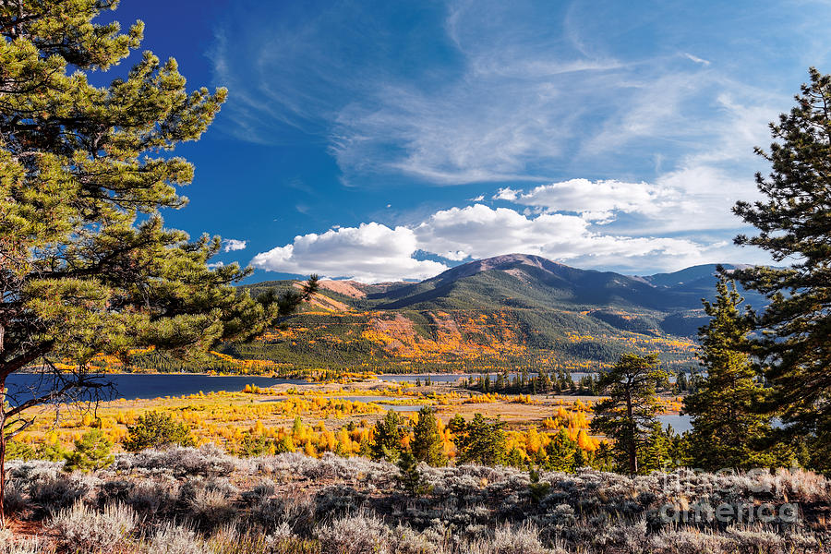

September In Colorado Mountains

Water
Of
Life

21 September 2025

W A T E R O F L I F E

Independent Christian Church—Conservative Lutheran Doctrine

Worship Service: 9:30 a.m.

Larry Cooper, Pastor E-Mail address:
lcooper@wateroflife.cc
Web Site:
www.wateroflife.cc

* * * * * * * * * * * * * * * * * * * * * * * * * * *

Sermon Text: Life Of David

Serving King Saul

* * * * * * * * * * * * * * * * * * * * * * * * * * *

